Distributed Operating System
HW-part 1
Raya Shafai 12010920
Lara Amer 12029590

Introduction:
The Bazar.com online bookstore project demonstrates the implementation of a distributed, microservice-based architecture for a simple book retail system. Designed as a two-tier web application, the system comprises three core microservices: a front-end client, a catalog service, and an order service, each running in isolated Docker containers. This report documents the system's architecture, functionality, and test results, highlighting key endpoints, interactions between services, and challenges encountered during development.

Project hierarchy:
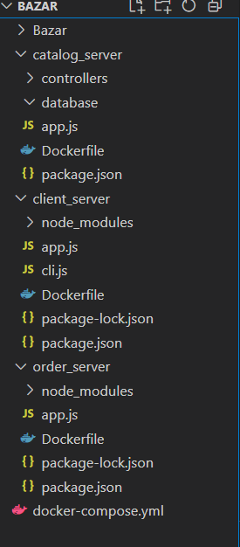

And we created a three containers for the three servers (catalog_server, client_server and order_server) in the Docker desktop then we turn them on:
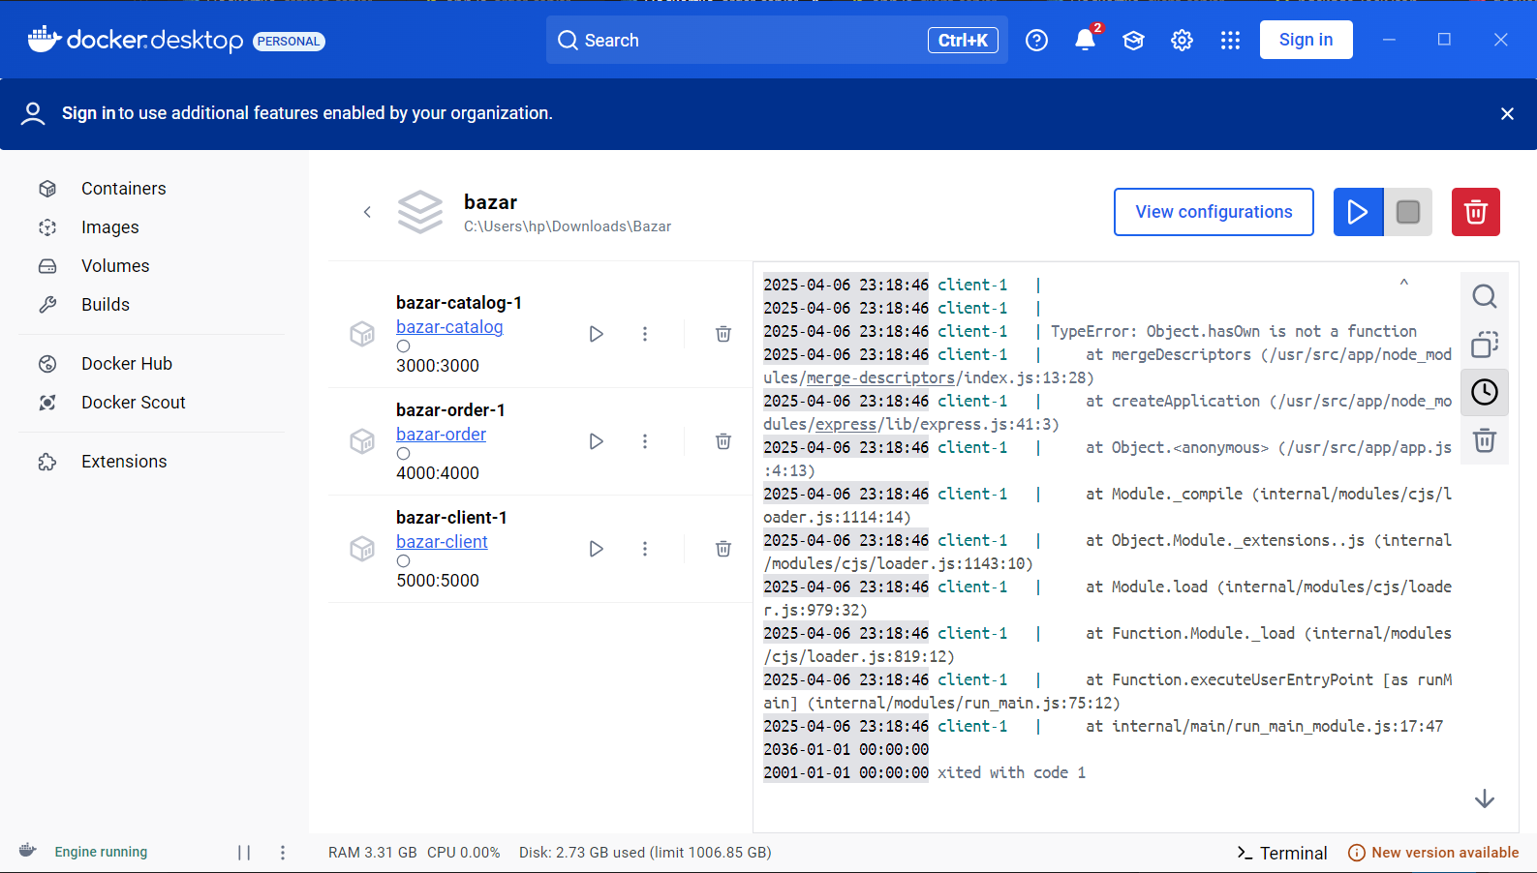
Running the project:
Cd the directory where docker-compose.yml file located
To build all containers : docker-compose up -d –build
To stop all containers : docker-compose down
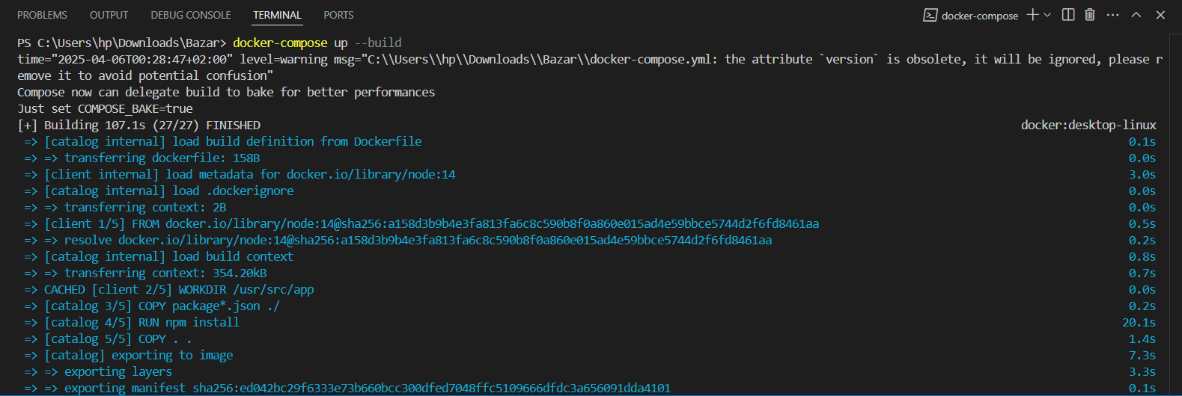
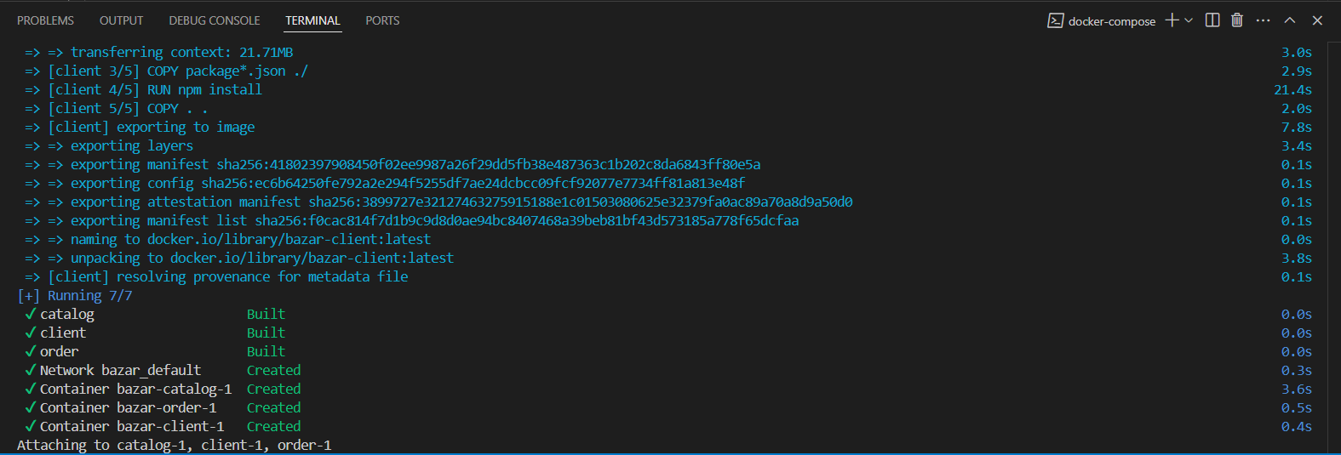

Here the Info by id operation in the catalog service:
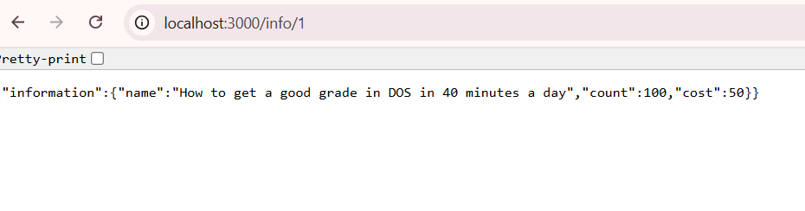

And here the search operation in the catalog service:
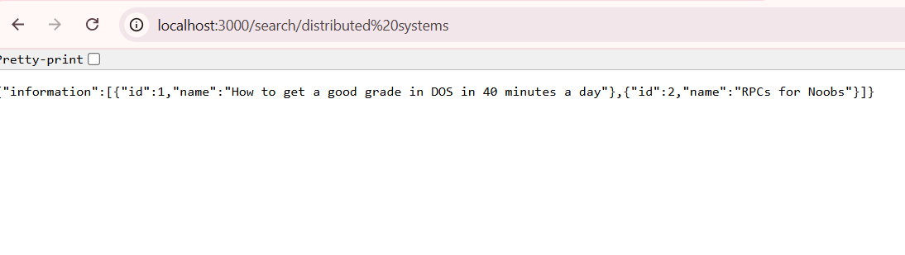
Here the search operation in the client service:
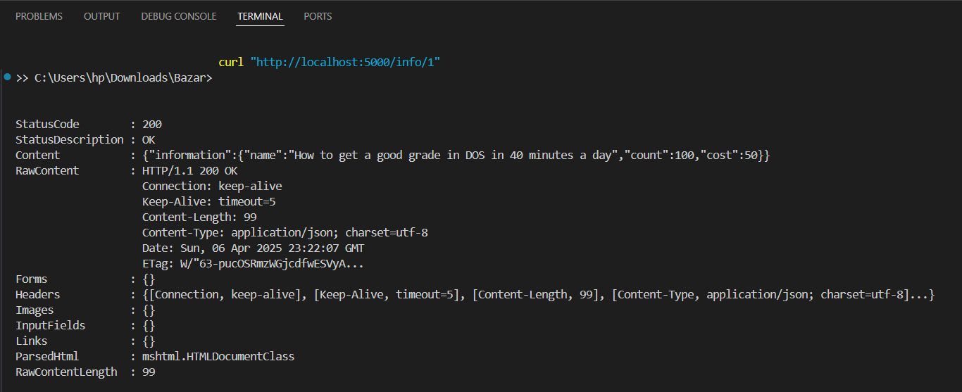

Here the Info by id and health operations in the catalog service:
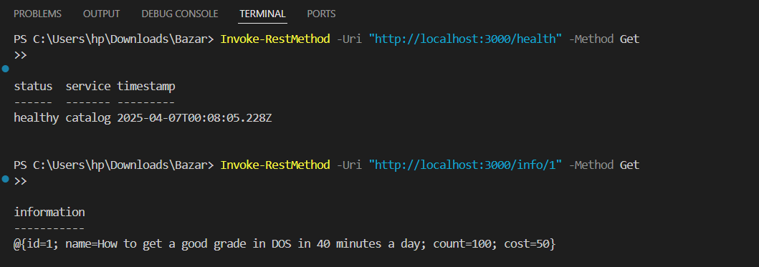

Here the search operation in the client service:
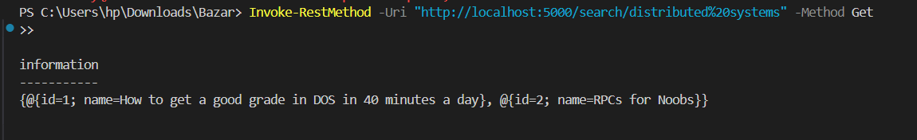

To get Info by id:
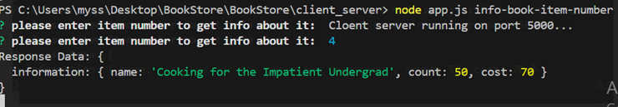

To search book by item number:
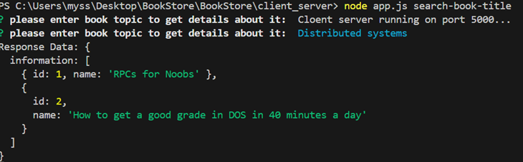

To purchase book:
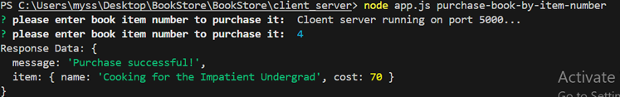

Conclusion:
We achieved seamless book search, inventory management, and purchase functionality. Key challenges, such as service discovery and error handling, were addressed, reinforcing the importance of resilience in distributed systems.
Future enhancements could include user authentication, automated scaling, and advanced monitoring. This implementation serves as a foundational model for building scalable, maintainable distributed systems.

